**Scenario: Handling New Releases with ASG**

Autoscaling group with fixed/dynamic is running  
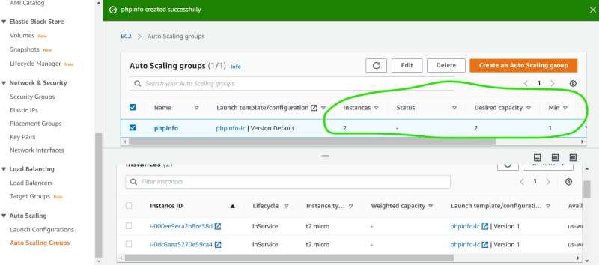

Now create a new AMI with one extra file echo "<h1> Version 2 </h1>" > /var/www/html/version.html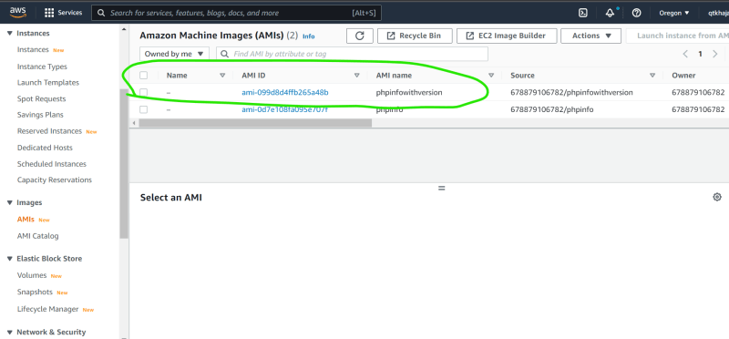

Let’s look at Launch Template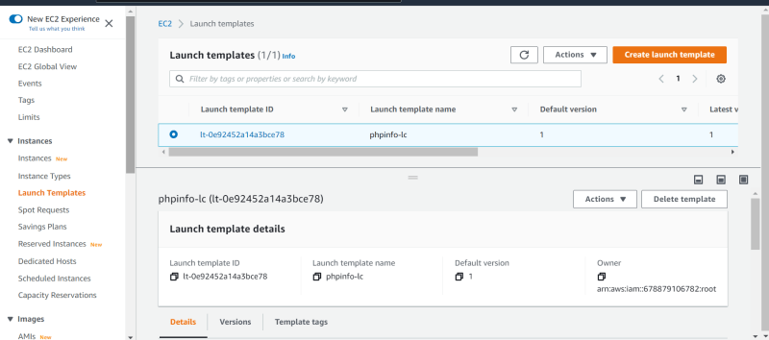  
<https://docs.aws.amazon.com/autoscaling/ec2/userguide/asg-instance-refresh.html> for an approach by using instance refresh

